Buddhism WebQuest
Instructions: Visit the following web-site in order to answer questions about Buddhism, one of the major religions throughout the world.

Place of Origin:
Founder:
Describe the story of how Siddharta Gautama became the Buddha (begin with where/when he was born, end with him searching for an answer to why suffering exists in the world):

Draw and name the three main Buddhist symbols:

Name:____________________ Name:____________________ Name:_______________________

Name the two places where Buddhists worship: __________________________ and __________________________________
What is Nirvana?
Buddhists believe that they can achieve enlightenment by following the Four Noble Truths and the Eightfold path. Name the Four Noble Truths:
1. _____________________________________________________________________________________________________
2. _____________________________________________________________________________________________________
3. _____________________________________________________________________________________________________
4. _____________________________________________________________________________________________________
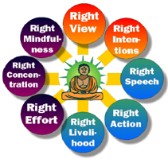
Name the components of the Eightfold Path:
- _____________________________________________
- ____________________________________________
- ____________________________________________
- ____________________________________________
- ____________________________________________
- ____________________________________________
- ____________________________________________
- ____________________________________________

