Federalist and AntiFederalist

Video: Carol Berkin on Federalists and Anti-Federalists

- Video Questions
  - What advantages did the Federalists have over the Anti-Federalists in arguing for the Constitution?
  - What does Berkin claim were the strongest arguments against the Constitution?
  - What did the states have to agree to do before the Constitution could be ratified?

Political Cartoon
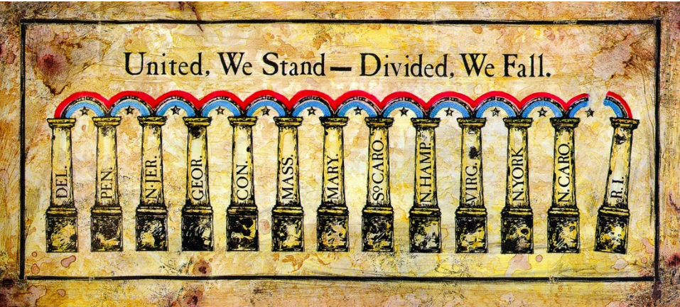
The rising pillars illustrates the order of state ratifications of the Constitution of the United States.

Political Cartoon Question:
- What is the main message the cartoonist is conveying?
- Reference the Ratification of the Constitution chart above to cite specific dates and vote counts to justify the artist's concern for Rhode Island.

Video: Bill of Rights
In 1791, due to the urging of the Anti-Federalists, a Bill of Rights was added to the US Constitution. Drafted by James Madison, the first ten amendments guaranteed civil protections and liberties for citizens.
Video Question
- How did some view Madison's plan of government?

1. What was the Articles of Confederation? Why did it fail?
2. What are the main differences between the Articles of Confederation and the Constitution?
3. What was the Federalist Papers? What were the three main ideas expressed in it about how the Constitution set up a strong government that preserved freedom? Why do people today think the Federalist Papers is important?
4. Hamilton said that judges need an “independent spirit.” What did he mean? Do you agree? Explain.
5. Why did the Federalists oppose a bill of rights? Do you agree? Explain.
6. How did the Bill of Rights get added to the Constitution?
7. Why did the Anti-Federalists oppose the Constitution? What do you thin

